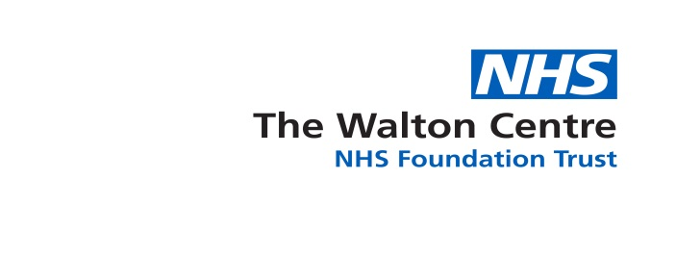
APPLICATION BY OR ON BEHALF OF PATIENT FOR HOSPITAL MEDICAL RECORDS

**PLEASE NOTE THIS FORM IS FOR PATIENT/FAMILY USE ONLY. ALL SOLICITOR/AGENCY REQUESTS SHOULD BE MADE VIA A HEADED COMPANY LETTER ALONG WITH SIGNED CONSENT**
For Office Use Only
Ref:  Date: | Rec:  Dsar:

EMAIL:
Section 1. Patient Details

(a) | Full name of patient (including previous surnames)
(b) | Date of Birth
(c) | Current Address – please complete the section below if you have moved since beginning your treatment.
(d) | Previous address
(e) | Email Address
(f) | Contact Telephone Number
(e) | Patient’s hospital or clinic contacts-please provide as much information as possible.
Date Attended (if known) |  | Hospital  (please note we do not release records or scans completed at other hospitals) | Ward/Clinic  (If known) |  | Consultant  (If known) | Hospital No (if known)

Section 2: Details of Records Requested

Please tell us the date range you are requesting if known.
Dates: | Start date | End Date

Please tick which of the following of your records you wish to receive?

**Please note X-Rays/Scan results take 4-6 weeks to be reported, please allow this timeframe to pass prior to requesting images**

All Records

Case Note History

Correspondence

Copies of images/scans

Theatre Documentation

Investigations

Nursing Records

Please select ONE of the following options:  Do you wish to view the medical records on hospital premises? or  ii. Do you wish to receive copies of the medical records via post?  Or  iii. Do you wish to receive copies of the medical records electronically via our online portal? (If yes please state the email address you would like these sent to.  ……………………………………………………………..  Confirm email address below  ………………………………………………………………. | YES/NO  YES/NO  YES/NO
DECLARATION

PART A (to be completed in ALL cases)

I declare that the information provided is correct to the best of my knowledge.
(please tick appropriate box)

- I am the patient.

- I am the patients representative and am authorised to deal on
their behalf

- I have responsibility for the patient, who is incapable of
Understanding the request or has consented to me making.
This request

- I have a claim arising from the patient’s death and wish to
Access information relevant to my claim and I attach details.
of the grounds of my claim and two items of proof of my identity.

- I am the deceased patient’s personal representative.
(Executor or Administrator of the Deceased person’s estate)
I have enclosed evidence that I am the Executor of the Will/Administrator
of the Estate and one item of evidence of my identity.

.
Signed:……………………………………… Date:………………………………………….

Name:……………………………………..............................................................
Address……………………………….…….……………………………………………………………………………………………
Tel No:………………………………………………………………………………….
Reference (if applicable): ……………………………………………………………

PART B (to be completed if section 2 above is applicable)

Authorisation

I am the patient and authorise the above named to act on my behalf and have access to my medical records.

Signed:………………………………..Date:………………………………………

Name:…………………………………………………………………………………
Address:…………………………………………………………………………………………………………………………………………………………………………
Authorisation and Identification

I enclose a COPY of two of the following forms of identification to support my application and to prove my identification:

Passport

Driving Licence

Bus Pass

Other formal Photographic ID (please tell us)

Additional Information

On receipt of the completed application the health record, will be passed to the appropriate clinicians for permission to release the copies you require.

Under new Data Protection laws the Trust is required to provide the information within one calendar month of receipt of the request. For the Trust to do this, can you please provide as much information as possible to allow the Trust to process your application.

Records can only be supplied up to the date this application form is completed. If any further records are required in the future a new application will have to be submitted.

Please return this form to: SAR/Legal Team. The Medical Records Department, The Walton Centre NHS Foundation Trust, Lower Lane, Fazakerley, Liverpool, L9 7LJ or by email to wcft.sarlegalrequests@nhs.net

